  YOUTH LEADERSHIP ENGAGEMENT | Abstract  The Youth Leadership Engagement segment investigates the readiness, aspirations, and challenges faced by Nigerian youth in pursuing leadership roles. Data from six surveyed states indicate low levels of youth participation in governance, with barriers including lack of mentorship, limited financial resources, and exclusion from political processes. However, findings also reveal strong public belief in the potential of youth to introduce innovation, address unemployment, and advance technology-driven policies.

Introduction
Nigeria’s youth, representing over 60% of the population, hold the potential to transform governance through fresh perspectives and innovation. However, as highlighted in the SICNI Profile and confirmed by the POP findings, they remain marginalized in political participation and leadership decision-making. Recognizing this, SICNI designed a youth-focused segment in the Public Opinion Poll to explore aspirations, readiness, and barriers to youth leadership.
The research objectives were to gauge young people’s interest in leadership, assess societal support for youth-led governance, and identify actionable pathways for increasing their participation. Conducted in Lagos, Enugu, Edo, Bauchi, Kano, and the FCT, the survey used stratified and multi-stage sampling to include urban, semi-urban, and rural populations. Special attention was given to the 18–35 age group, while also capturing views from older citizens for comparative insights. Respondents participated in 30-minute structured interviews that probed civic engagement, perceived obstacles, and priority areas for youth-led change. The achieved coverage provides a rich foundation for targeted youth empowerment programs.
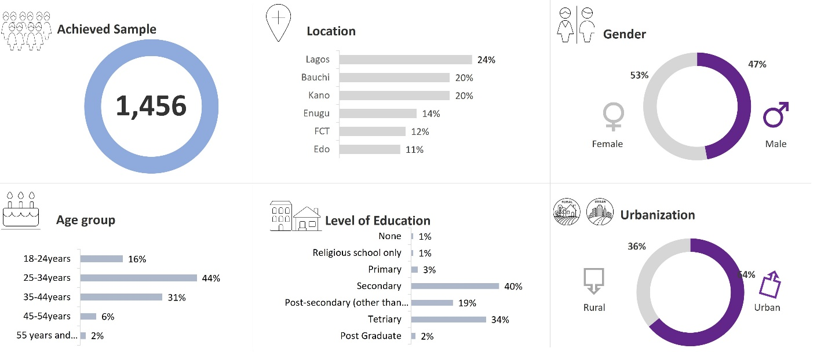
Data was collected through 30-minute structured, face-to-face interviews in strategically selected urban and rural locations, resulting in a dataset that reflects the voices of a diverse cross-section of Nigerians.

Research Findings
The survey results point to the following critical insights into the current landscape
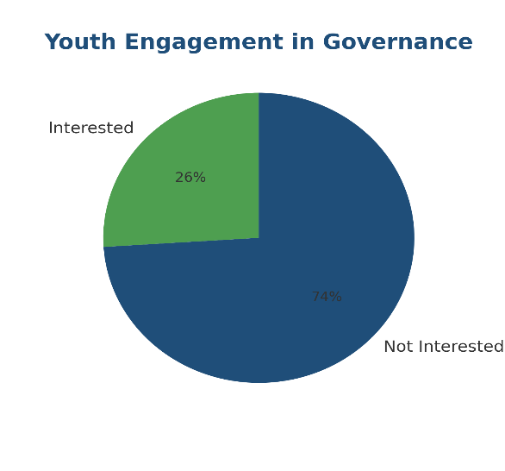
1. Youth Engagement in Governance
The data shows that only about a quarter of young people express strong interest in governance, suggesting a worrying trend of disengagement among the demographic that represents Africa’s future.

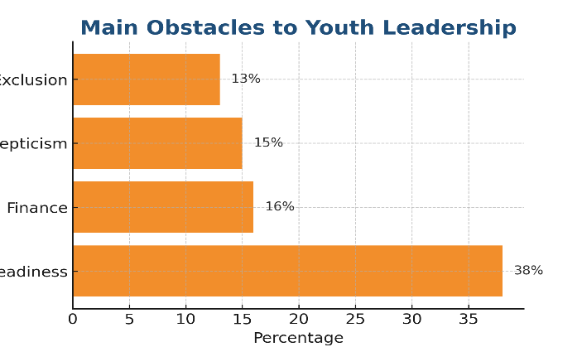
2. Main Obstacles to Youth Leadership
Low readiness, limited financial resources, public skepticism, and exclusion from decision-making structures were the main factors cited as blocking young leaders from emerging.

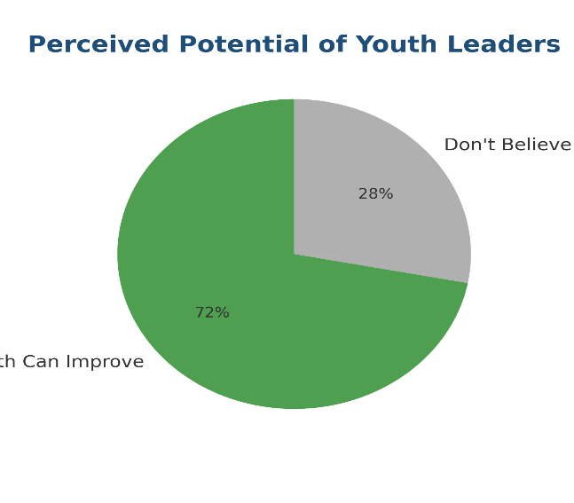
3. Perceived Potential of Youth Leaders
Nearly three-quarters of respondents believe young leaders have the potential to improve governance if given the opportunity, signaling hope for generational change.

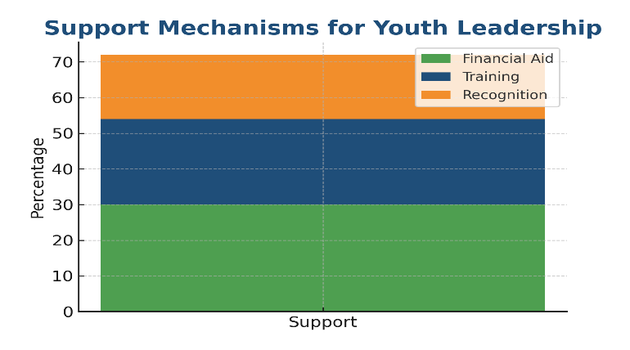
4. Support Mechanisms for Youth Leadership
Key support mechanisms suggested include targeted financial aid, leadership training, and public recognition programs to encourage youth participation in governance.

Analysis

The findings highlight a disengaged youth population that, while possessing significant potential, feels excluded from decision-making and constrained by lack of resources. The gap between perceived potential (high) and current engagement (low) is particularly concerning, as it indicates systemic barriers rather than lack of interest or ability. Youth readiness challenges—such as limited political exposure and insufficient leadership training—suggest the need for targeted capacity-building programs. With proper mentorship and institutional support, the emerging generation could reshape governance in meaningful ways.

Proposed Intervention
In response to these findings, SICNI proposes the following actionable strategies for meaningful change:
- Youth Leadership Fellowship
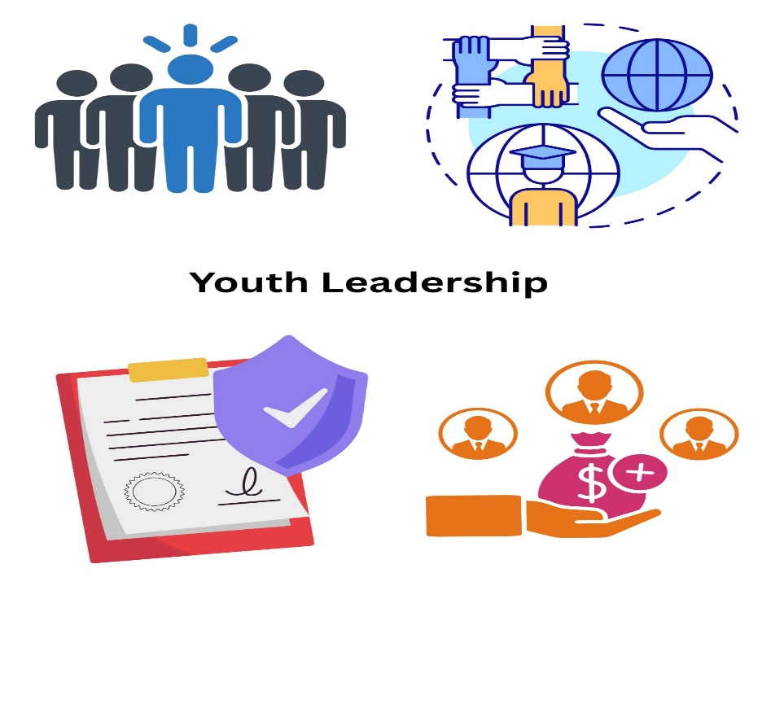 | A competitive program offering leadership training, mentorship, and internships within government and civil society organizations.
- Civic Education in Schools and Communities
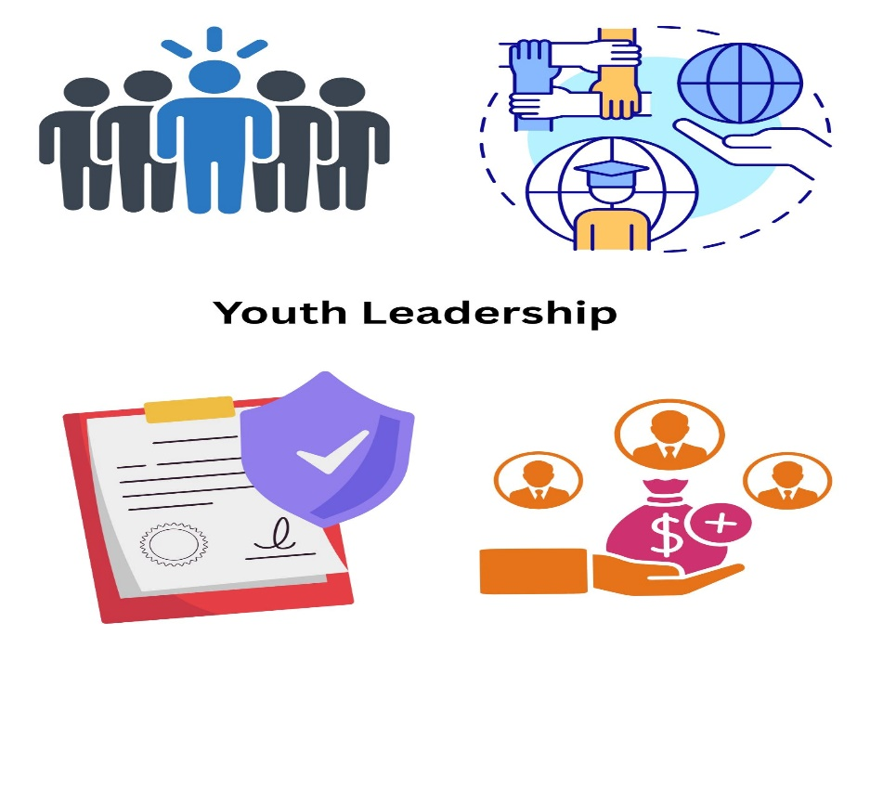 | Embedding governance and leadership modules into secondary and tertiary education curricula.
- Youth Policy Labs
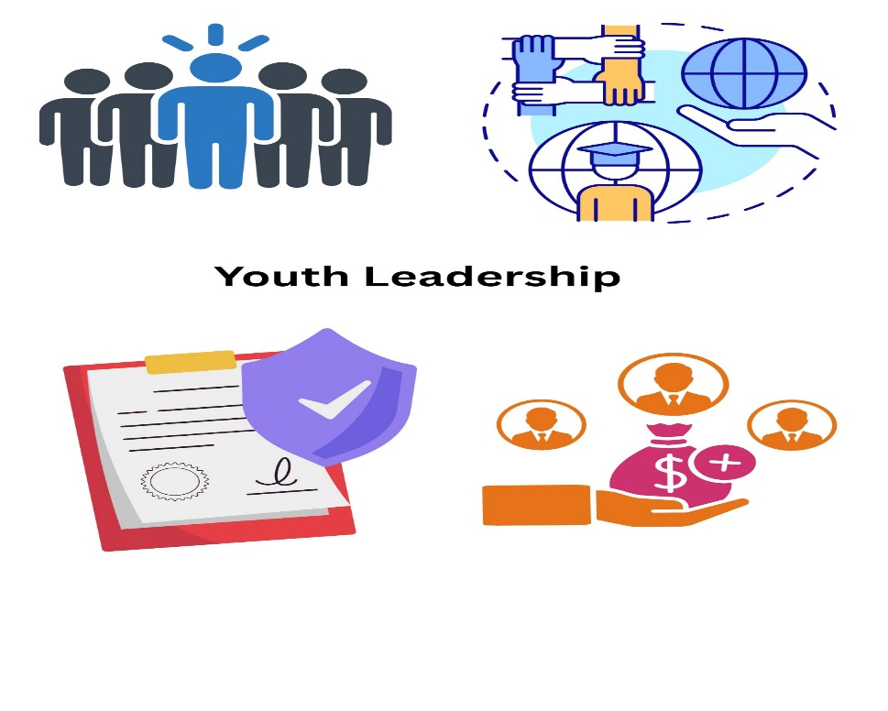 | Small, collaborative think tanks where young people co-create policy ideas and present them to policymakers.
- Leadership Micro-fund
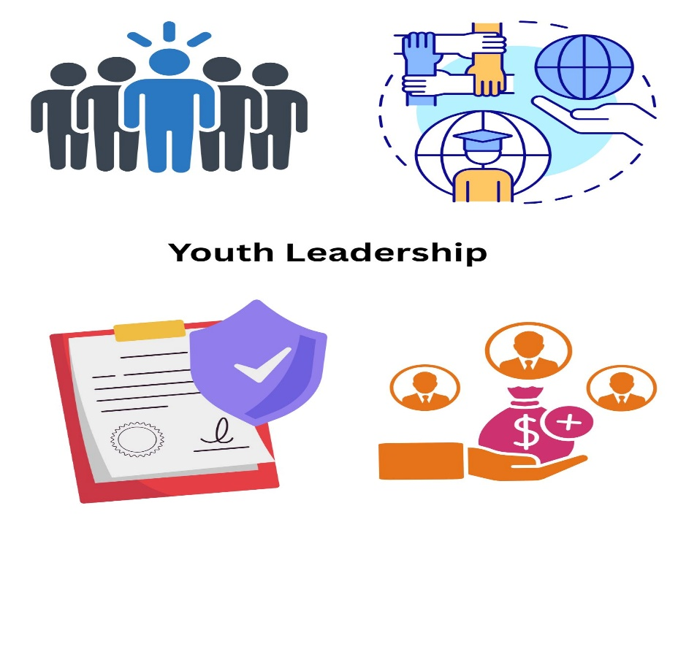 | A pool of funds dedicated to supporting youth-led civic initiatives, advocacy projects, and political campaigns.

